# [https://avatars2.githubusercontent.com/u/4156894?v=3&s=100](http://www.calstatela.edu/centers/hipic) CIS3200 Term Project Tutorial

#### Authors: Andrew Rosalino, Tan Huynh, Sareena Grajeda, Aylin Ignacio

#### Instructor: [Jongwook Woo](https://www.linkedin.com/in/jongwook-woo-7081a85)

#### Date: 05/17/2020

**Lab Tutorial**

05/17/2020

**Vehicle Collision Analysis With Kibana**

**Objectives**

In this hands-on lab, you will learn how to:

* Upload data to Kibana using Data Visualizer
* Set up mapping for data to be read correctly
* Visualize data in pie charts
* Visualize data in bar graphs
* Visualization of data on geo point map.

**Platform Spec**

* Elasticsearch/Kibana
* # of nodes: 4
* Total Memory Size: 341.2 MB / 846 MB

Step 1: Upload data to Kibana

This step is to download the data set and upload it to be used in Kibana

1. Go to <http://geohub.lacity.org/datasets/ladot::collisions-2009-2013-switrs> and download the CSV spreadsheet file.
2. Go to elastic.co and sign in with your account.
3. In the deployment menu that appears, click the Kibana quick link to enter the Kibana home page.
4. On the left-hand tool bar, click machine learning, then go to the Data Visualizer tab.
5. Click upload and select the CSV file
6. Verify that the time field is COLLISION_DATE and click Import

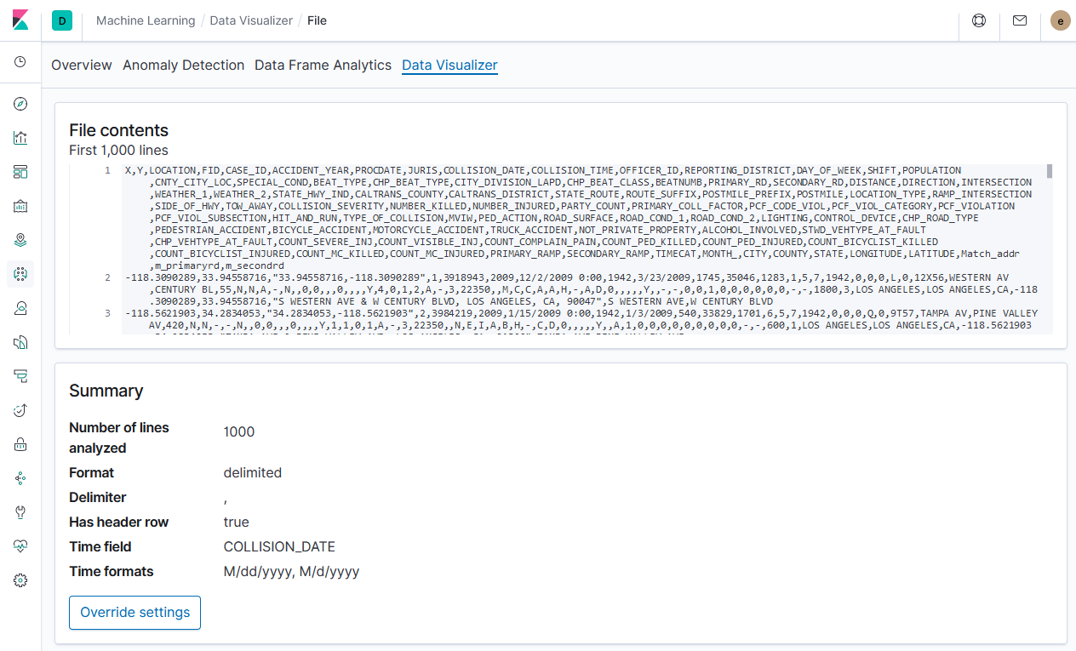

1. In the mapping section under Advanced on the next page, change the current mapping for Location from keyword to “geo_point”. This allows Kibana to recognize the Location column from the CSV file as type “geo_point” which is the required type to be used in maps.

},

"LOCATION": {

"type": "geo_point"

},

1. Name the Index collision-data and click Import. Importing the file will take several minutes.

* Step 2: Visualize data in pie charts

This step is to use the data we uploaded and visualize it as useful pie charts.

1. Go to Management on the left-hand tool bar and select Index Patterns. Select Create Index Pattern from the top left.
2. In the Index Pattern window type in collision* click next
3. Select the COLLISION_DATE from the time filter field name window, and then create index pattern.
4. Select Visualize from the left-hand tool bar, then select create visualization, and select pie chart from the New Visualization menu that pops up.
5. Select the collision* index pattern that we created.
6. Select add buckets and add split slices.
7. Select add again and add another split slices.
8. Ensure that the metrics and the buckets are configured as follows:

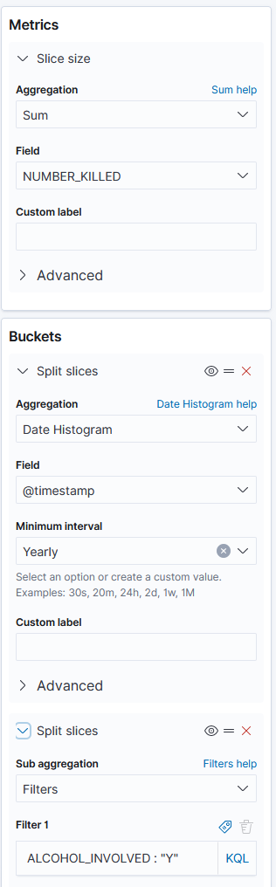

1. Ensure the date range is from 2009-2013 and click the play button to visualize the data

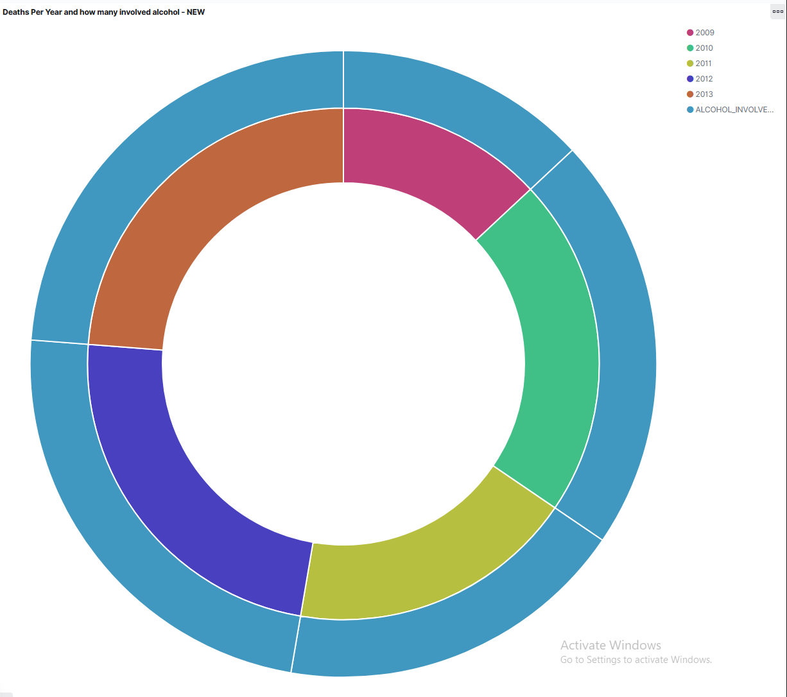

* Step 3: Visualize data in bar graphs

This step is to visualize the data in a useful bar graph.

1. Select Visualize from the left-hand tool bar, then select create visualization, and select bar chart from the New Visualization menu that pops up.
2. Select the index pattern and then configure X-Axis and Split Series as follows, leaving Y-Axis as it is.

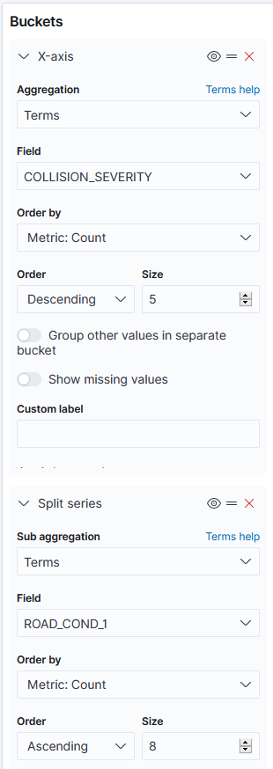

1. Select the Metrics & Axes tab and under metrics change Mode to “Normal”
2. Click the play button to visualize the data.

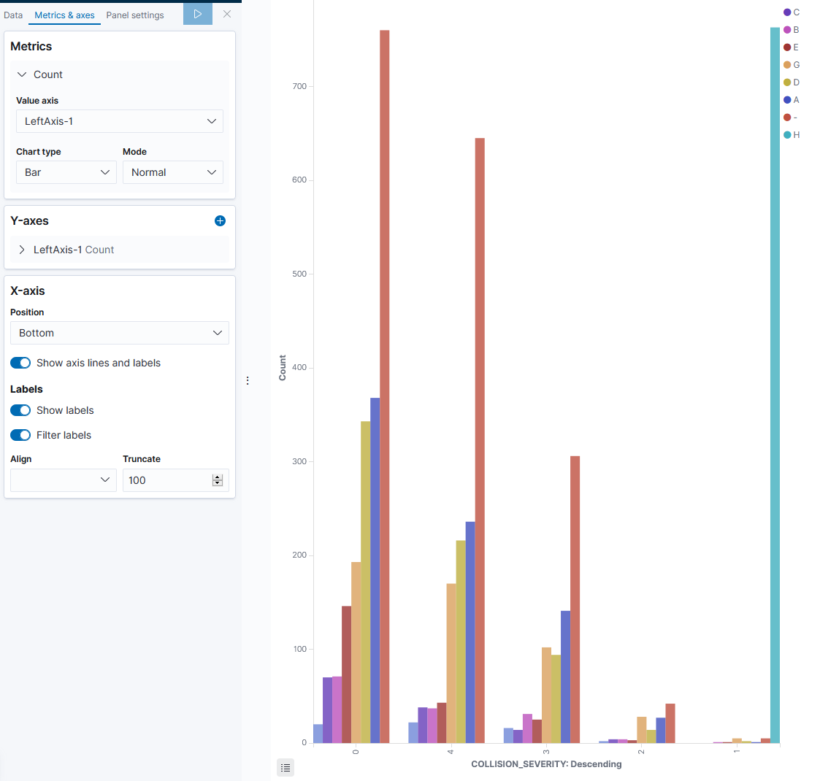

* Step 4: Visualize data using maps

This step is to use the map visualization in Kibana to plot the locations of all accidents in certain conditions.

* 1. In the visualizations menu select Create Visualization and select Map from the window that follows.
  2. Click add layer and select Documents
  3. Select the collision* index pattern in the window on the next screen and ensure that “Location” is the selected Geospatial field.
  4. Configure the layer as shown and then save and close.

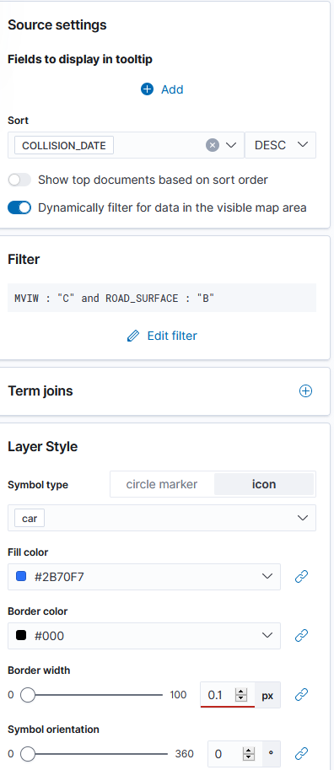

* 1. Verify that the date matches 2009-2013 from our data and click refresh.
  2. The result should show all collisions between two vehicles during wet road surfaces.

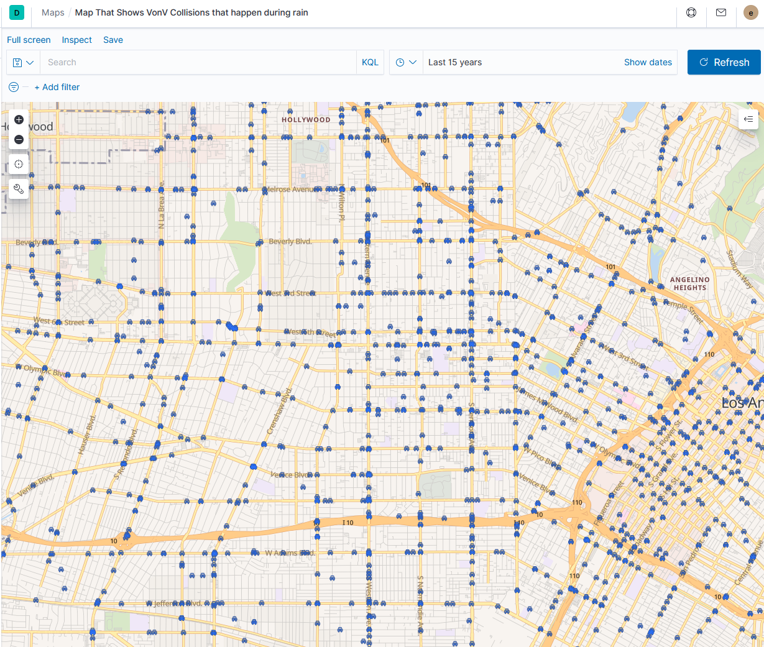

References

* 1. URL of Data Source, <http://geohub.lacity.org/datasets/ladot::collisions-2009-2013-switrs>
  2. URL of our Github, <https://github.com/CIS3200Group3/Group-3---Project>